Rolling correlation: NZDUSD and USDJPY
Method 05 / daily log returns / windows 20, 60, 100 / Low-value

Study setup
Logical pair: NZDUSD , USDJPY
Broker symbols: NZDUSD_i , USDJPY_i
Tier: Low-value (low_value)
Snapshot: 2026-11-03_majors_alpari_D1
Timeframe: D1
Matched return window: 1999-01-05 to 2026-11-02 (UTC bar dates)
Matched return count (rows before rolling): 7185
Dropped unfinished last bar dated 2026-11-03 UTC after a tick-volume check against the prior complete day.
Rolling windows W: 20, 60, 100 trading days
Live-shaped n for each score: n = W (not the full history length)
Complete matched rows (CSV): NZDUSD-USDJPY_Rolling_D1.csv
Complete matched rows (HTML): NZDUSD-USDJPY_Rolling_D1_data.html

Method carried forward
Rolling Pearson r is computed on matched daily log returns of close, ln(close_t / close_t-1), in the broker quote direction. Quotes are not inverted. For each day t with a full window, r_W uses the last W matched return pairs ending at t. That live-shaped sample size is W (20, 60, or 100), not the full multi-year history. The first W-1 days have no score. r is symmetric under swap of the two symbols. A high |r| in one window does not prove cause, lead-lag, or a trading signal. Short windows are noisier; long windows are slower to reflect a break.
How to read a live day: after both daily candles close, the newest r_20 uses the last 20 matched log returns, r_60 the last 60, and r_100 the last 100. Compare those three to each other and to the full-sample baseline below. A break is when the short window moves far from the baseline or flips sign while the baseline was meaningful.

Full-sample Pearson baseline (method 01 v001)
Copied full-sample Pearson r for NZDUSD-USDJPY: -0.133568. This is a historical average link, not the live state.

Rolling results
W | latest_r | mean | median | min | max | std | pct_|r|>=0.4 | pct_|r|>=0.7 | n_roll
20 | -0.023279 | -0.257749 | -0.317782 | -0.881307 | 0.928943 | 0.359165 | 47.25 | 9.08 | 7166
60 | -0.401882 | -0.241865 | -0.27768 | -0.757288 | 0.849509 | 0.302452 | 39.05 | 1.59 | 7126
100 | -0.4564 | -0.233108 | -0.257818 | -0.714113 | 0.737877 | 0.286866 | 36.13 | 0.38 | 7086
n_roll is the number of days that had a complete window. pct_|r|>=0.4 and pct_|r|>=0.7 are the share of those days where the absolute rolling correlation cleared the threshold.

Conclusion
For NZDUSD and USDJPY, full-sample Pearson baseline r=-0.1336. Latest rolling scores: r_20=-0.0233, r_60=-0.4019, r_100=-0.4564. Stability: moderate window-to-window variation. Agreement with baseline: r_20=-0.023 near baseline; r_60=-0.402 far from baseline (0.27); r_100=-0.456 far from baseline (0.32). Tier line: low interest historically; check only if a short window spikes. This is a monitoring summary, not a trade signal.

What to look at in this file next time
1) Latest r_20 vs r_60 vs r_100 in the results table. 2) Whether short-window latest has the same sign as the baseline. 3) The rolling chart for stretches where |r| collapsed. 4) The CSV if you need a different chart later.

Charts
Rolling Pearson r (20 / 60 / 100)
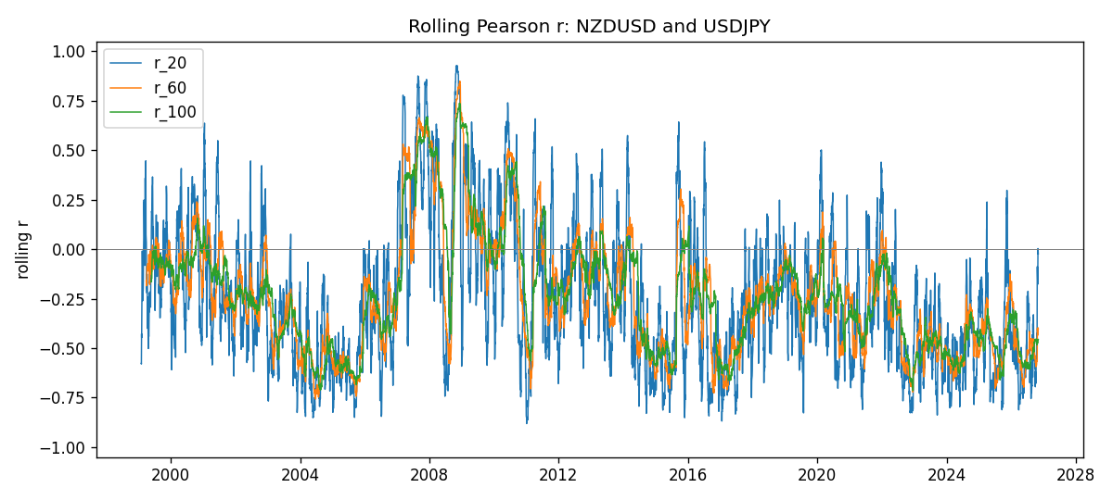
Daily closes

Daily log returns
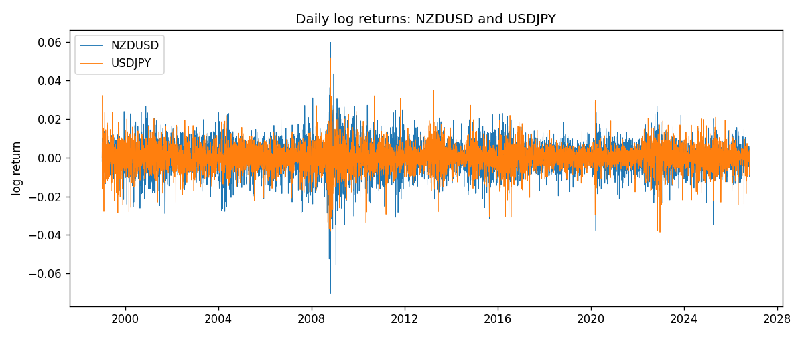

Data report
Every matched row with r_20, r_60, and r_100 is in the sibling CSV and HTML. This Word section holds column summaries and the first and last 15 rows of the rolling table.
Columns: time, NZDUSD_close, USDJPY_close, NZDUSD_tick_volume, USDJPY_tick_volume, NZDUSD_log_return, USDJPY_log_return, r_20, r_60, r_100
Column summaries
column | count | mean | std | min | 25% | 50% | 75% | max
NZDUSD_close | 7185 | 0.656486 | 0.108202 | 0.3907 | 0.59157 | 0.6684 | 0.72502 | 0.8822
USDJPY_close | 7185 | 113.821 | 19.2395 | 75.811 | 104.38 | 111.015 | 120.69 | 163.851
NZDUSD_tick_volume | 7185 | 68717.7 | 123141 | 16 | 5585 | 33899 | 58511 | 1.12768e+06
USDJPY_tick_volume | 7185 | 106344 | 179438 | 149 | 9948 | 53202 | 92889 | 1.80351e+06
NZDUSD_log_return | 7185 | 1.284e-05 | 0.0076404 | -0.0702743 | -0.00425236 | 0.00022967 | 0.00458145 | 0.0596684
USDJPY_log_return | 7185 | 4.789e-05 | 0.00620418 | -0.039082 | -0.00320044 | 0.00011802 | 0.00340223 | 0.0518402
r_20 | 7166 | -0.257749 | 0.359165 | -0.881307 | -0.531308 | -0.317782 | -0.0461425 | 0.928943
r_60 | 7126 | -0.241865 | 0.302452 | -0.757288 | -0.484426 | -0.27768 | -0.0706504 | 0.849509
r_100 | 7086 | -0.233108 | 0.286866 | -0.714113 | -0.455465 | -0.257818 | -0.0809144 | 0.737877
First 15 matched rows
time | NZDUSD_close | USDJPY_close | NZDUSD_log_return | USDJPY_log_return | r_20 | r_60 | r_100
1999-01-05 | 0.5372 | 111.92 | -0.00185977 | -0.000178683
1999-01-06 | 0.5383 | 112.77 | 0.00204556 | 0.00756602
1999-01-07 | 0.5417 | 111.33 | 0.00629632 | -0.0128516
1999-01-08 | 0.5414 | 110.8 | -0.000553965 | -0.00477199
1999-01-11 | 0.547 | 109.02 | 0.0102904 | -0.0161954
1999-01-12 | 0.5441 | 112.6 | -0.00531575 | 0.0323104
1999-01-13 | 0.5387 | 113.52 | -0.00997422 | 0.00813732
1999-01-14 | 0.5386 | 113.52 | -0.000185649 | 0
1999-01-15 | 0.5382 | 114.15 | -0.000742942 | 0.00553434
1999-01-18 | 0.5372 | 114.16 | -0.00185977 | 8.76002e-05
1999-01-19 | 0.5382 | 113.52 | 0.00185977 | -0.00562194
1999-01-20 | 0.5404 | 112.91 | 0.00407937 | -0.00538799
1999-01-21 | 0.5426 | 113.87 | 0.00406279 | 0.00846641
1999-01-22 | 0.5361 | 114.56 | -0.0120517 | 0.00604126
1999-01-25 | 0.5342 | 113.72 | -0.00355041 | -0.00735942
Last 15 matched rows
time | NZDUSD_close | USDJPY_close | NZDUSD_log_return | USDJPY_log_return | r_20 | r_60 | r_100
2026-10-13 | 0.56127 | 158.305 | 0.00473262 | -0.00189328 | -0.568675 | -0.585229 | -0.454768
2026-10-14 | 0.55918 | 158.317 | -0.00373065 | 7.58002e-05 | -0.470011 | -0.584263 | -0.474471
2026-10-15 | 0.56185 | 158.024 | 0.00476349 | -0.00185243 | -0.468265 | -0.575451 | -0.475139
2026-10-16 | 0.56509 | 157.964 | 0.0057501 | -0.000379761 | -0.470011 | -0.569365 | -0.481548
2026-10-19 | 0.56616 | 158.517 | 0.00189171 | 0.00349468 | -0.424971 | -0.561243 | -0.475103
2026-10-20 | 0.56827 | 158.16 | 0.00371993 | -0.00225466 | -0.449521 | -0.565223 | -0.476396
2026-10-21 | 0.57003 | 158.108 | 0.00309233 | -0.000328835 | -0.291171 | -0.561252 | -0.483066
2026-10-22 | 0.56815 | 156.755 | -0.00330352 | -0.00859427 | -0.0879828 | -0.41035 | -0.464062
2026-10-23 | 0.56991 | 156.81 | 0.00309299 | 0.000350804 | -0.0884533 | -0.400404 | -0.470344
2026-10-26 | 0.56826 | 157.458 | -0.00289939 | 0.00412387 | -0.147691 | -0.416241 | -0.473436
2026-10-27 | 0.56811 | 157.894 | -0.000263999 | 0.00276517 | -0.177052 | -0.43486 | -0.474041
2026-10-28 | 0.56261 | 157.743 | -0.00972839 | -0.000956795 | -0.0975773 | -0.411255 | -0.459799
2026-10-29 | 0.56296 | 157.683 | 0.000621907 | -0.000380438 | -0.00644363 | -0.40611 | -0.455097
2026-10-30 | 0.56307 | 157.516 | 0.000195377 | -0.00105965 | 0.00312553 | -0.396624 | -0.455127
2026-11-02 | 0.56161 | 157.933 | -0.0025963 | 0.00264385 | -0.0232789 | -0.401882 | -0.4564

